Full Stack Development with MERN - Project Documentation

# 1. Introduction

Project Title: Booknest - Online BookNest-where Stories Sestle

Booknest is a dynamic, full-stack e-commerce platform designed to provide a seamless online marketplace for books. It serves as an intermediary between book buyers and sellers, creating a rich, user-friendly experience for all parties involved. The platform allows buyers to explore a wide range of books, add their favorite titles to wishlists, and make purchases through a secure online checkout system. Sellers can easily upload their book listings, manage inventory, and engage with customers through their personalized seller dashboard. The system is built with the MERN stack (MongoDB, Express, React, Node.js), ensuring scalability, performance, and a modern user interface for both users and sellers. Booknest aims to revolutionize how people discover and purchase books online, making it a one-stop solution for readers and sellers alike.

Team Members:

🡪Team Id: LTVIP2025TMID45078

🡪Team size:4

🡪Team member 1:Name: Mohan Mani Shankar

Email id: [mohanmanishankar01@gmail.com](mailto:mohanmanishankar01@gmail.com)

Phone number:7671856676

Roll Number: 23A91A6171

🡪Team member 2 :Name Konda Vijay Vardhan

Email id: [vijayvardhan3333@gmail.com](mailto:vijayvardhan3333@gmail.com)

Phone number:8328048556

Roll Number:22P31A0597

🡪Team member 3:Name Mangi Rishitha Sravanthi

Email id: [rishithasravanthi878@gmail.com](mailto:rishithasravanthi878@gmail.com)

Phone number: 6300030213

Roll Number: 23A91A0440

🡪Team member 4: Name : Kuchimanchi Venkata Subramanya sau

E-mail :

Phone

Roll Number :

# 2. Project Overview

Purpose: The purpose of Booknest is to create a comprehensive online marketplace that caters to both book enthusiasts and sellers. It offers users the ability to browse a diverse collection of books, add them to their wishlist, and make secure purchases from the comfort of their homes. For sellers, the platform provides an intuitive interface to easily list and manage their books, reach a broader audience, and track their sales. By combining a rich user experience with efficient seller tools, Booknest aims to simplify the process of buying and selling books online while fostering a vibrant community of readers and authors.

Features:

- User Registration and Login

-accessing books (cart, whishlist,order).

- Book Listing by Sellers

- Wishlist and Cart Functionality

- Admin Management

# 3. Architecture

Frontend: React.js (providing a responsive and dynamic user interface with reusable components, and handling state management for various features like the wishlist, cart, and user profiles).

Backend: Node.js with Express.js, handling RESTful APIs for user authentication, book listing, and order management. It ensures smooth communication between the frontend and the database.

Database: MongoDB using Mongoose ODM, which simplifies data modeling and validation. Collections include users, sellers, admins, books (items), and orders. MongoDB allows flexible data storage and fast queries, supporting scalability as the platform grows.

# 4. Setup Instructions

Prerequisites: Node.js, MongoDB, npm

Installation Steps:

1. Clone the repository

2. Navigate to Backend directory: `cd Backend`

3. Run `npm install` to install dependencies

4. Create `.env` file and add MongoDB URI and JWT secret

5. Start the server: `npm start`

# 5. Folder Structure

Backend/

├── db/

│ ├── Admin/Admin.js

│ ├── Seller/{Additem.js, Sellers.js}

│ └── Users/{cart.js, myorders.js, userschema.js, Wishlist.js}

├── middleware/auth.js

├── server.js

frontend/

├── public/

│ └── vite.svg

├── src/

│ ├── Admin/

│ │ ├── Ahome.jsx

│ │ ├── Alogin.jsx

│ │ ├── Anavbar.jsx

│ │ ├── Asignup.jsx

│ │ ├── Awhole.css

│ │ └── items.jsx

│ ├── Seller/

│ │ ├── Book.jsx

│ │ ├── List.css

│ │ ├── Myproducts.jsx

│ │ ├── Orders.jsx

│ │ ├── Shome.jsx

│ │ ├── Slogin.jsx

│ │ ├── Snavbar.jsx

│ │ ├── Ssignup.jsx

│ │ └── swhole.css

│ ├── User/

│ │ ├── Login.jsx

│ │ ├── Myorders.jsx

│ │ ├── OrderItem.jsx

│ │ ├── Products.jsx

│ │ ├── Signup.jsx

│ │ ├── uhome.css

│ │ ├── Uhome.jsx

│ │ ├── Uitem.jsx

│ │ ├── Unavbar.jsx

│ │ └── whole.css

│ ├── Components/

│ │ ├── Footer.jsx

│ │ ├── Home.jsx

│ │ ├── Home.css

│ │ ├── Adbook.jsx

│ │ ├── Book.jsx

│ │ ├── List.css

│ │ ├── Myproducts.jsx

│ │ ├── Orders.jsx

│ │ └── Shome.jsx

├── App.jsx

├── App.css

└── index.js

# 6. Running the Application

Backend:

- Navigate to Backend: `cd Backend`

🡪install node_modules to start server(to push in github repository team has been deleted node_modules)

- Run server: `npm start` or node server.js

Frontend:

- navigate to frontend :’cd frontend’

- run in localhost: npm run dev.

# 7. API Documentation

POST /user/signup - Create new user

POST /user/login - Login existing user

GET /items - List all books

POST /additem - Seller adds a book

POST /wishlist - Add item to wishlist

POST /cart - Add item to cart

GET /cart/:userId - Get items in user's cart

POST /orders - Place a new order

GET /orders/:userId - Get user's order history

GET /admin/dashboard - Get admin dashboard stats

GET /admin/users - Get all registered users (admin only)

GET /admin/orders - Get all orders placed (admin only)

# 8. Authentication

Authentication is handled using middleware (`middleware/auth.js`).

Likely token-based (JWT assumed).

-user can login signup

-seller can login and signup

-Admin can login and signup.

# 9. User Interface

The below pictures showing about booknest project interface

🡪main home page:

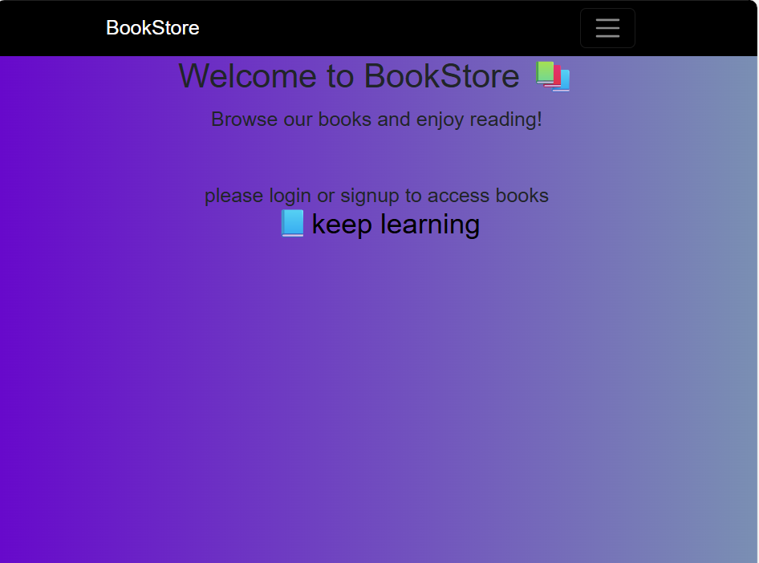

🡪login page for user:

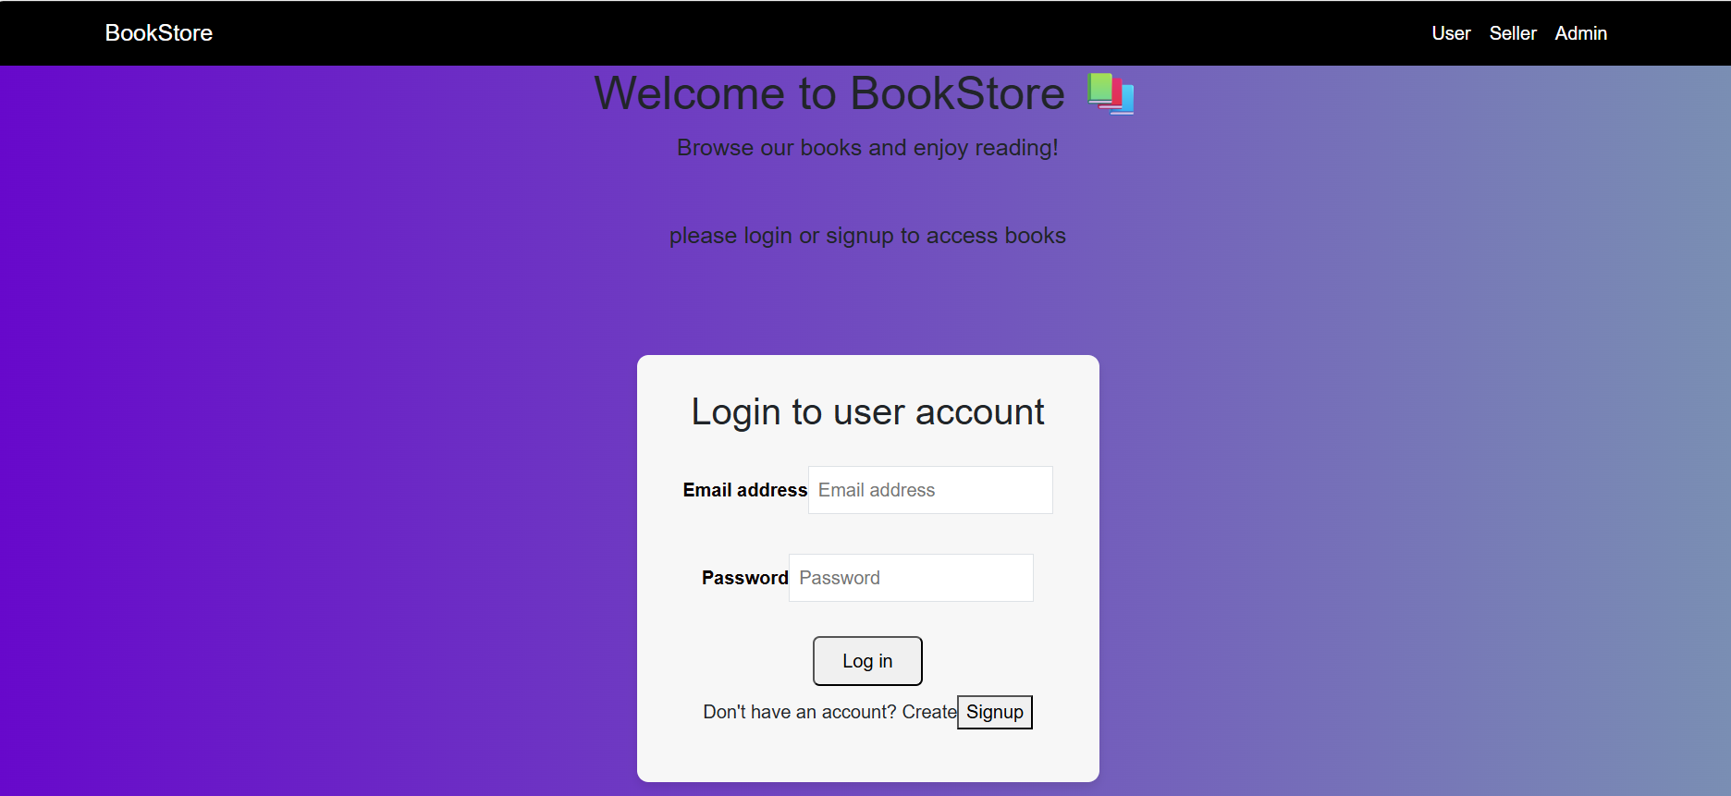

🡪login page for seller: 

🡪login page for Admin:

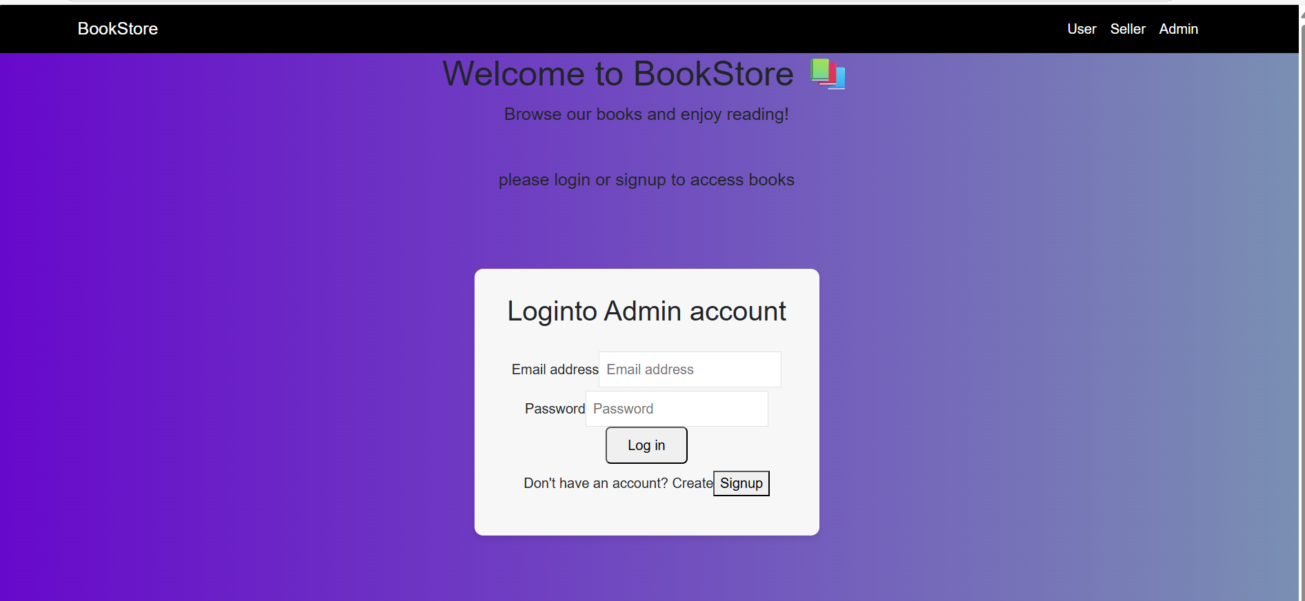

🡪user Home page

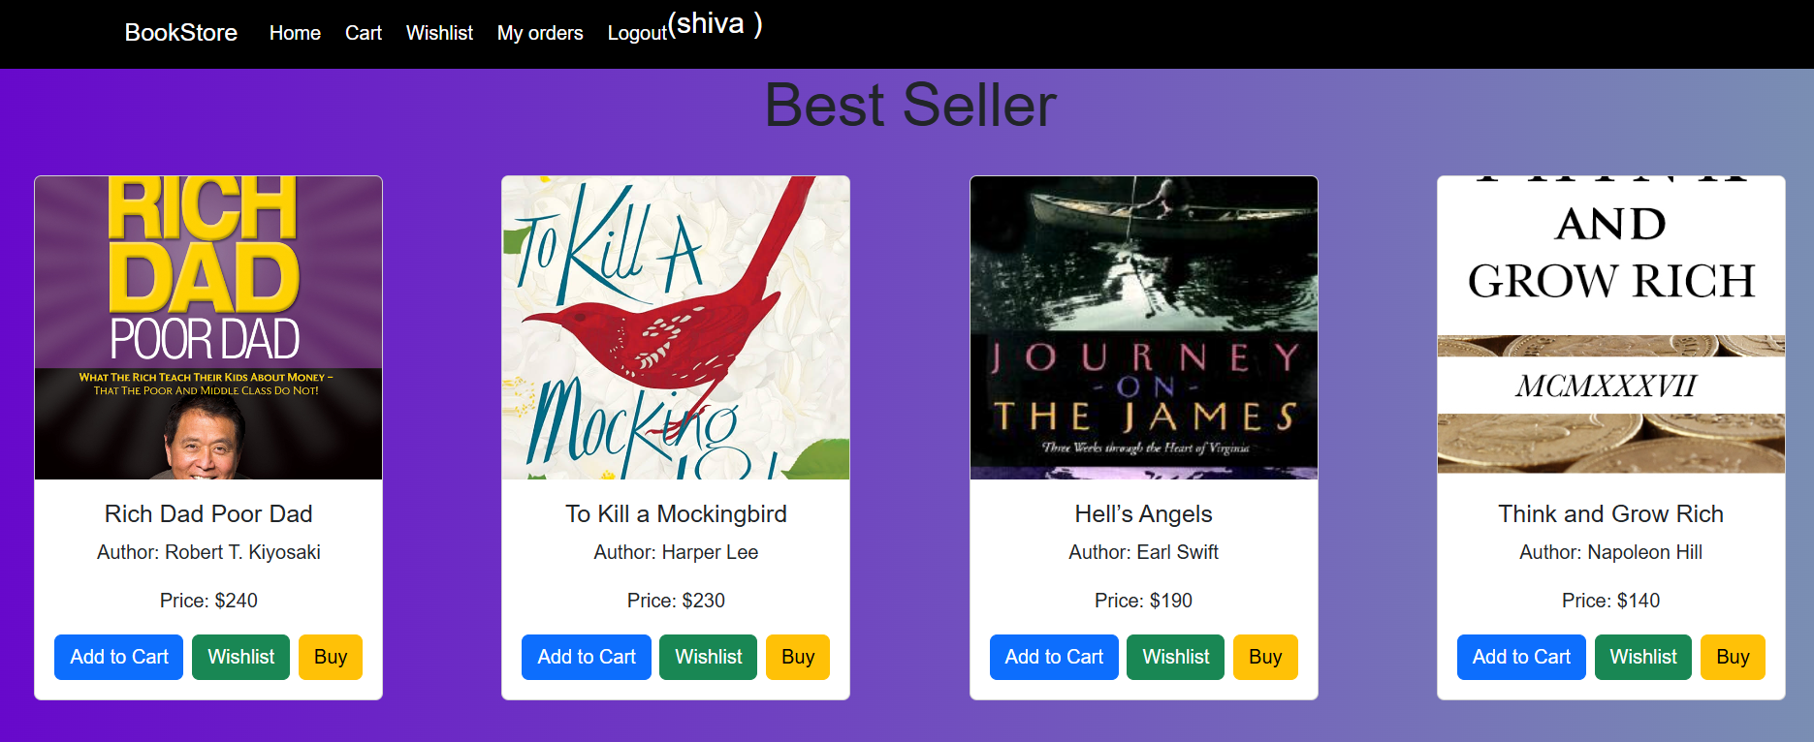

# 10. Testing

Testing strategy (e.g., Postman for API testing).

**Testing Strategy**

To ensure the reliability and correctness of the application, the following testing strategies were used:

**1. API Testing – Postman**

* **Tool Used**: Postman
* All backend API endpoints were tested using Postman before integrating with the frontend.
* The API responses were verified for:
  + Correct HTTP status codes (e.g., 200, 201, 404, 500)
  + Proper data format (JSON structure)
  + Validations (e.g., missing fields, incorrect credentials)
  + Error handling messages

**Examples of API tested using Postman:**

* POST /register – User registration
* POST /login – User authentication
* GET /books – Fetch all books
* POST /cart/add – Add book to cart
* GET /wishlist – Get user wishlist
* POST /order – Place order

**2. Frontend Manual Testing**

* Manual testing was conducted by interacting with the application through the browser.
* Verified that each feature works as expected:
  + Login/logout flow
  + Navigation between pages
  + Conditional rendering (e.g., different roles like User/Seller/Admin)
  + Add to Cart, Wishlist, Orders functionalities

**3. Edge Case Testing**

* Checked how the app behaves with:
  + Empty input fields
  + Invalid login credentials
  + Trying to add the same book multiple times
  + Accessing protected routes without login

**4. Developer Console Debugging**

* Used Chrome Developer Tools (Console & Network tabs) to:
  + Monitor API calls
  + Catch JavaScript errors
  + Verify frontend-backend data flow

# 11. Screenshots or Demo

# *screenshots about Booknest whole project

🡪login page for user:



🡪login page for seller: 

🡪login page for Admin:



🡪user Home page



🡪user cart page:

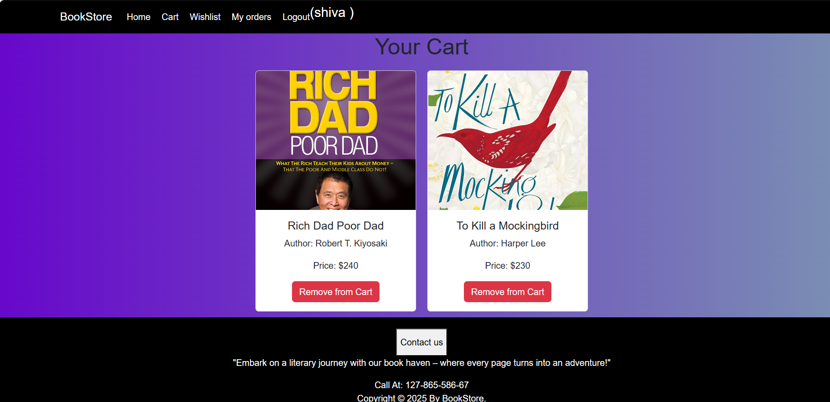

🡪user wishlist page:

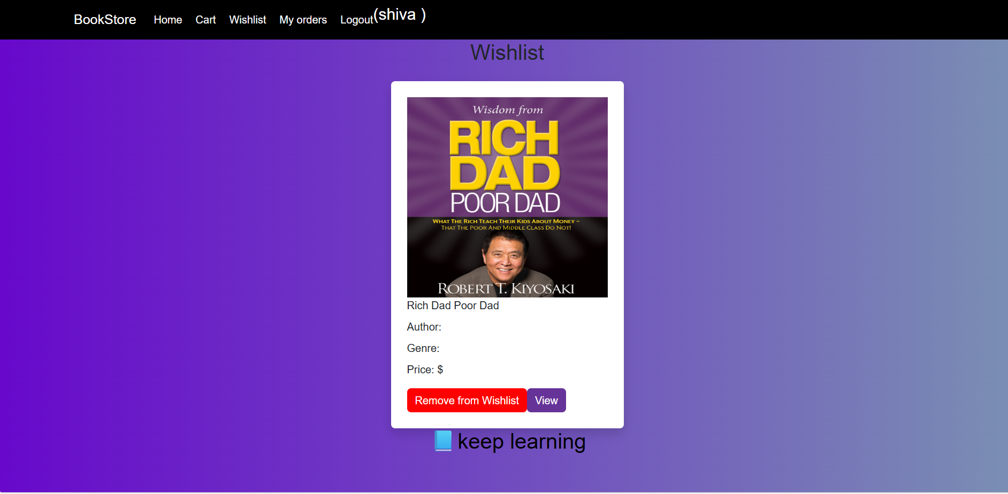

🡪user order page:

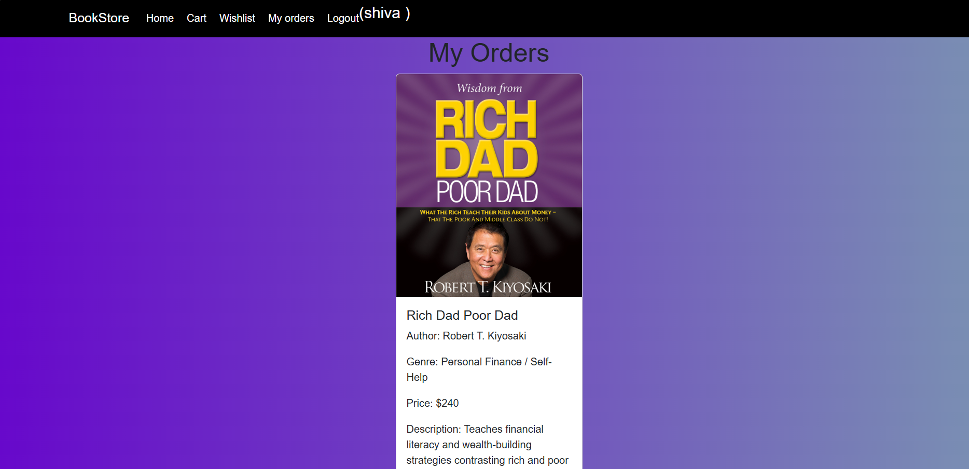

🡪seller home page(consisting dashboard);

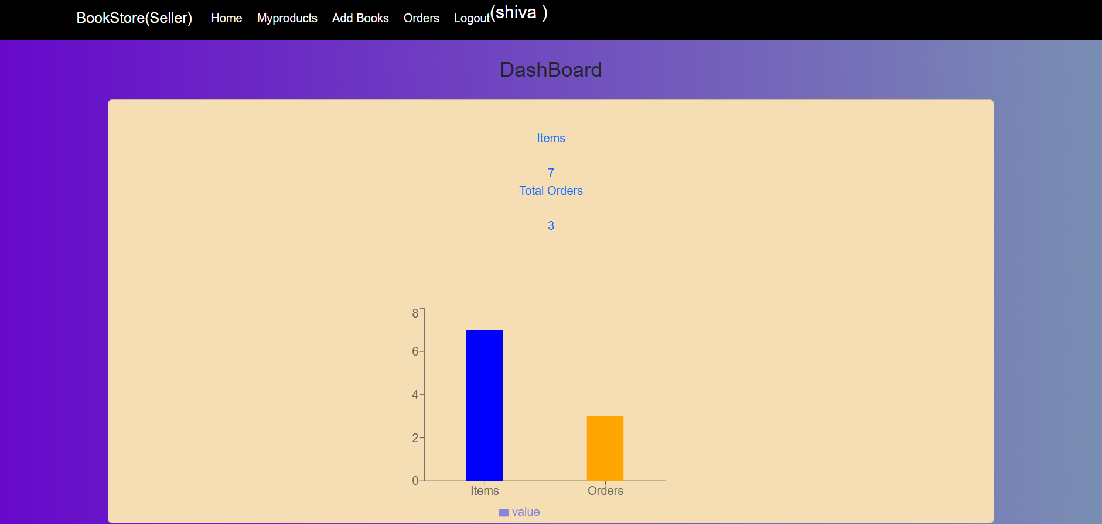

🡪seller books list:

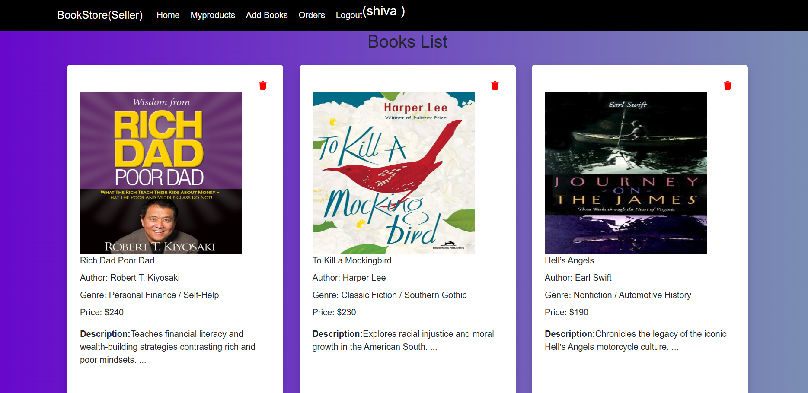

🡪addbook page for seller:



🡪orders page (in seller):



🡪Admin home page(showing dashboard);about count of vendors, users..

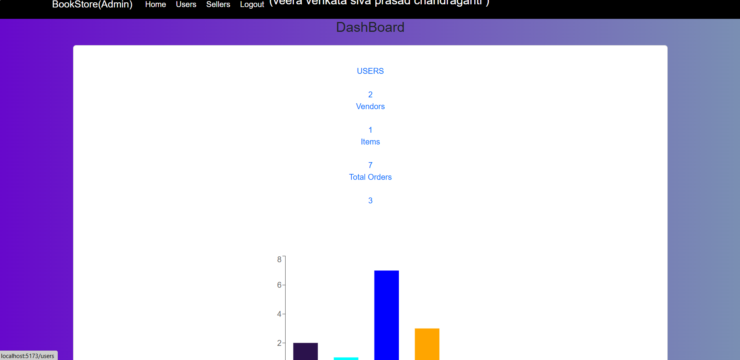

🡪user’s information(in Admin ):

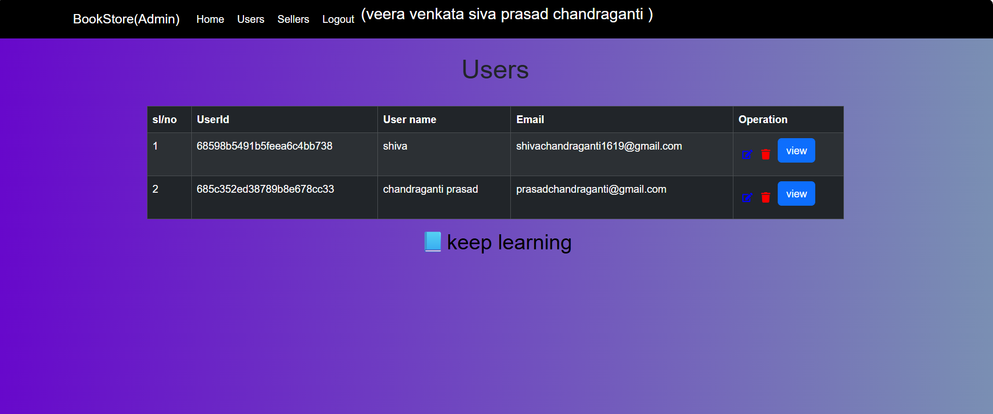

🡪seller’s information(in Admin);



# 12. Known Issues

No major known issues reported at this stage.

# 13. Future Enhancements

Add features like payment integration, search filters, etc.